Config backup report from opsramp
Tuesday, July 1, 2025
5:53 PM

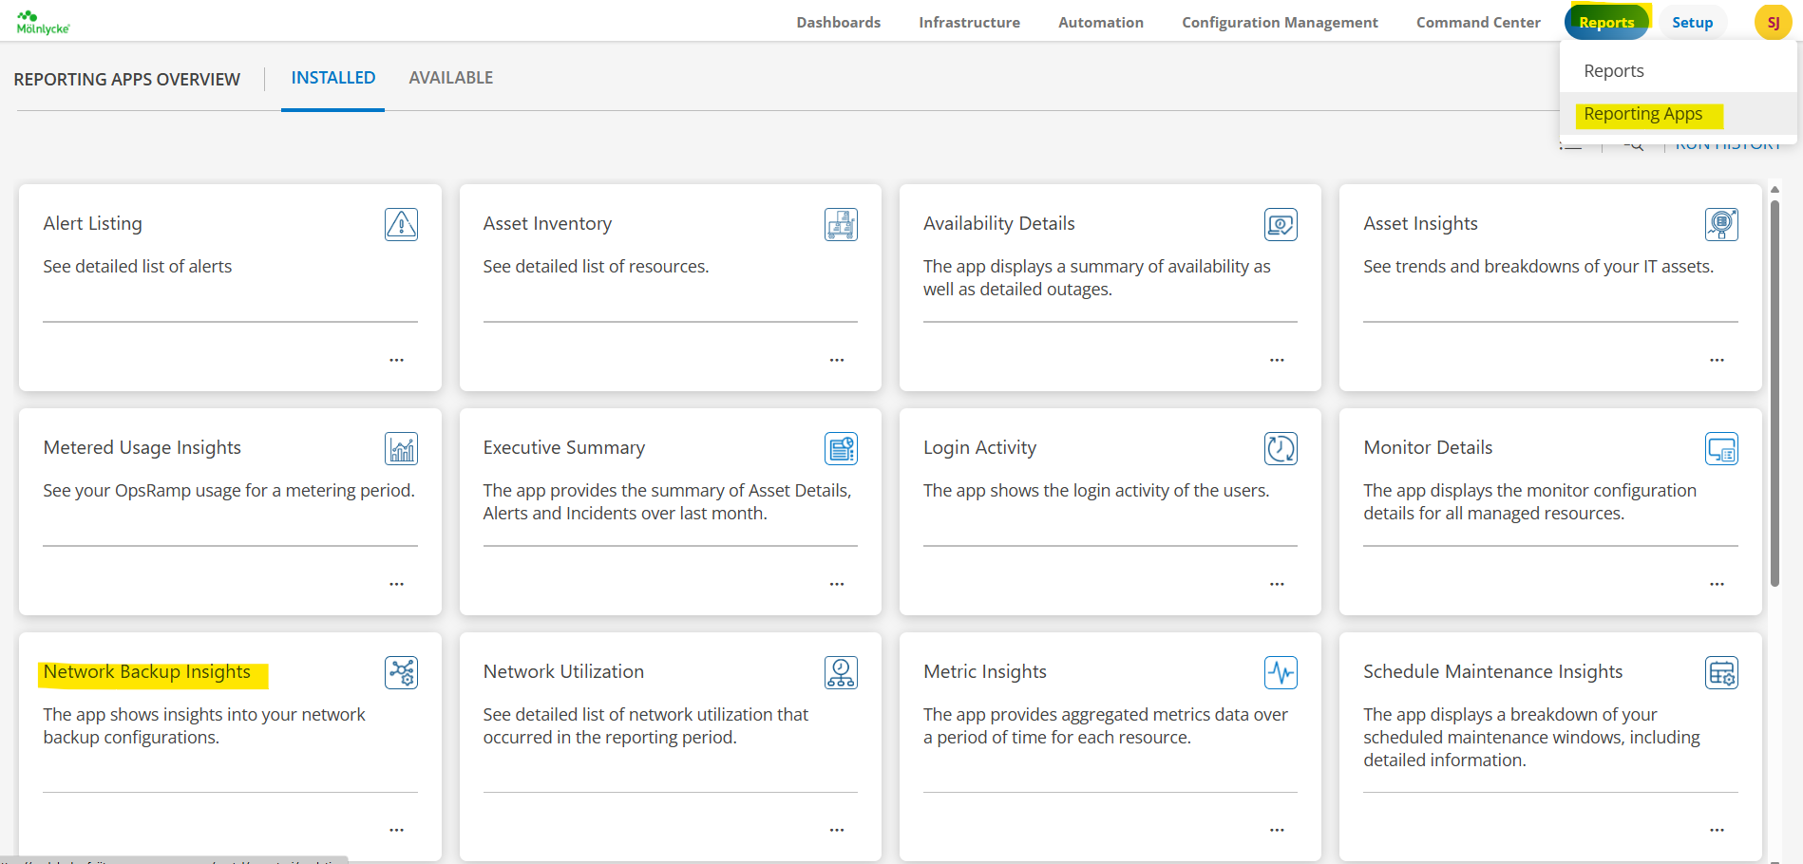

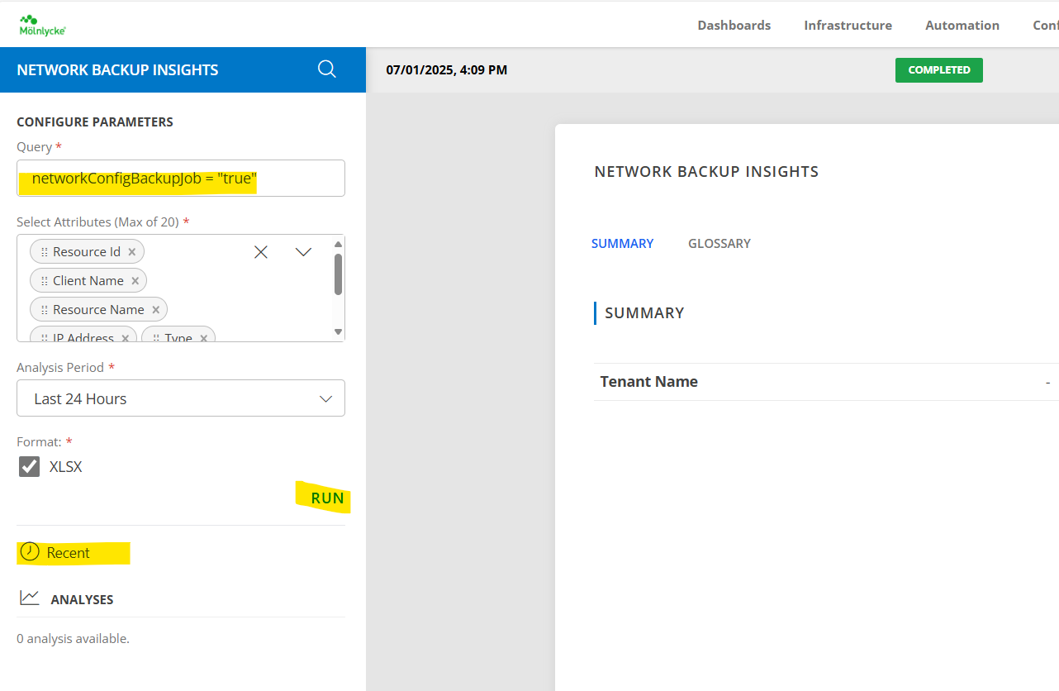

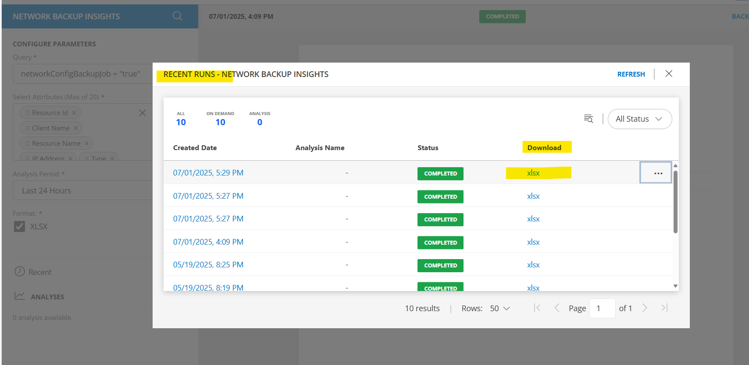

<<Mölnlycke_Network Backup Insights-07-01-2025 10-39-17.xlsx>>

